https://www.nlog.nl/nlog-mapviewer/brh/3351578031?lang=nl
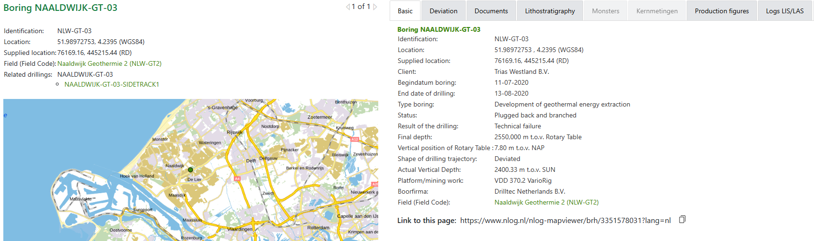
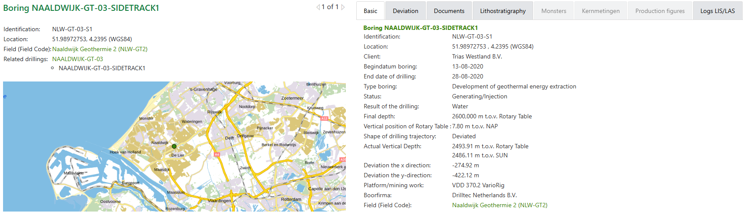

Boring NAALDWIJK-GT-03
Category | Document
Borehole/Well - Final Report | End of Well Report(28 Aug 2020) # 1  End of Well Report(28 Aug 2020) # 10  End of Well Report(28 Aug 2020) # 11  End of Well Report(28 Aug 2020) # 2  End of Well Report(28 Aug 2020) # 3  End of Well Report(28 Aug 2020) # 4  End of Well Report(28 Aug 2020) # 5  End of Well Report(28 Aug 2020) # 6  End of Well Report(28 Aug 2020) # 7  End of Well Report(28 Aug 2020) # 8  End of Well Report(28 Aug 2020) # 9
Documents with borehole measurements | Smoothed MEM Gamma Ray(892-2533)(05 Aug 2020) # 1  Smoothed MEM Gamma Ray(892-2533)(05 Aug 2020) # 2
Documents with profile data of the borehole | Final Well Report(31 Aug 2020)  Lithology Log (Composite)(0-2600)(21 Aug 2020)  Technical Log (Composite)(0-2550)(13 Aug 2020)  Well Seeker - Directional Survey(23 Aug 2020) # 1  Well Seeker - Directional Survey(23 Aug 2020) # 2
Borehole sample research reports | DEVLI project: Stratigraphy and tectonostratigraphy of the Delfland and Vlieland subgroups, Upper Jurassic and Lower Cretaceous - Broad Fourteens Basin, West Netherlands Basin and neighbouring areas. (20 Nov 2024)

Boring NAALDWIJK-GT-03-SIDETRACK1
Category | Document
Borehole/Well - Final Report | End of Well Report(28 Aug 2020) # 1  End of Well Report(28 Aug 2020) # 10  End of Well Report(28 Aug 2020) # 11  End of Well Report(28 Aug 2020) # 2  End of Well Report(28 Aug 2020) # 3  End of Well Report(28 Aug 2020) # 4  End of Well Report(28 Aug 2020) # 5  End of Well Report(28 Aug 2020) # 6  End of Well Report(28 Aug 2020) # 7  End of Well Report(28 Aug 2020) # 8  End of Well Report(28 Aug 2020) # 9
Documents with borehole measurements | Borehole Profile(902-2591)(22 Aug 2020)  Compensated Neutron Log - Compensated Z-Densilog - Gamma Ray Log(902-2572)(22 Aug 2020)  Digital Spectralog(902-2566)(22 Aug 2020)  Smoothed MEM Gamma Ray(1450-2581)(22 Aug 2020) # 1  Smoothed MEM Gamma Ray(1450-2581)(22 Aug 2020) # 2  X-Multipole Array Acoustilog - Compensated Neutron Log - Compensated Z-Densilog - Digital Spectralog(902-2594)(22 Aug 2020)  X-Multipole Array Acoustilog - Gamma Ray Log(902-2583)(22 Aug 2020)
Documents with profile data of the borehole | Final Well Report(31 Aug 2020)  Lithology Log (Composite)(0-2600)(21 Aug 2020)  Well Seeker - Directional Survey(23 Aug 2020) # 1  Well Seeker - Directional Survey(23 Aug 2020) # 2
Documents with test result borehole | Product test data(21 Sep 2020)
Borehole sample research reports | DEVLI project: Stratigraphy and tectonostratigraphy of the Delfland and Vlieland subgroups, Upper Jurassic and Lower Cretaceous - Broad Fourteens Basin, West Netherlands Basin and neighbouring areas. (20 Nov 2024)

